(District Name) Guide to Using the eSD Parent Portal

This editable document allows districts to customize parent-facing “how to” guides.

Recommendations for use:
Add the district and or school logo
Add the district’s unique portal URL
Remove tab images and explanations if features are not enabled
Create grade or school specific guides to match features available in each school.

To access the Parent Portal, Go To:

Insert hyperlink to district’s unique URL

Insert image of district’s unique Login Page

Contents
Where to Start 3
Change Your Password 4
Portal Navigation 5
Other Features and Functions 6
Messages 7
Messages Inbox 7
Existing Message Threads 8
Compose a New Message 8
Contact Verification 9
Digital Access Survey 12
Student Information Pages 13
Profile Tab 13
Attendance Tab 14
Schedule Tab 15
Discipline Tab 15
Health Tab 16
Transcript Tab 16
Report Card Tab 17
Buses Tab 17
Course Requests Tab 18
New Course Request 18
Gradebook Tab 19
Progress Reports Tab 20
Assessments Tab 21
Fees Tab 21
Standards Based Report Cards Tab 22
Standards Based Progress Reports Tab 22
Account Settings 24
Update Account Information 24
Personal Information 25
Environmental Settings 26
Messaging Preferences 27
Picture Settings 28

Where to Start
Go to your district provided Parent Portal URL.
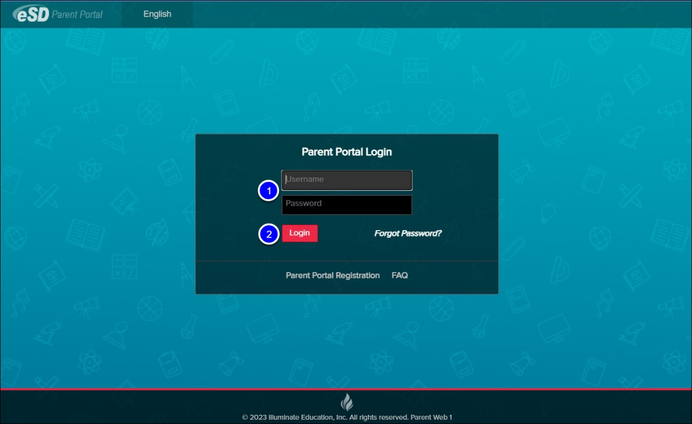
- Enter your Username and Password.
- Select Login.
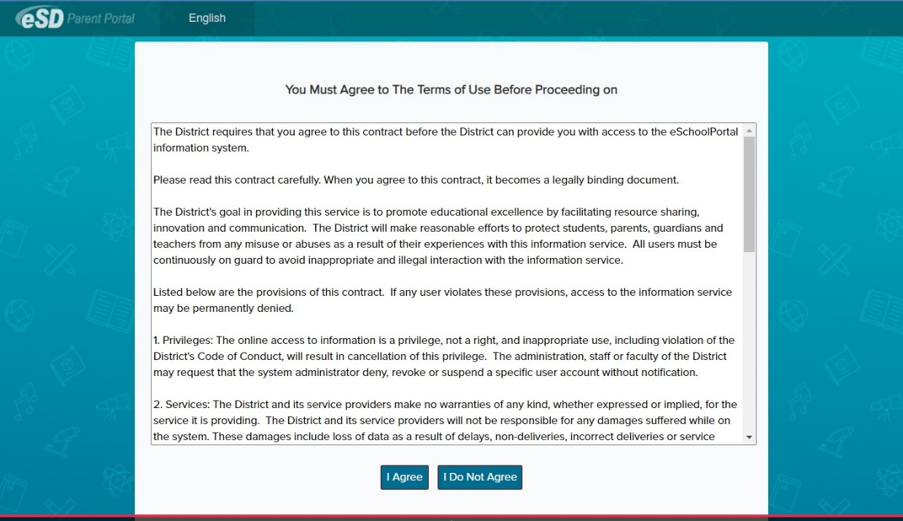
If this is your first time logging in, you must agree to the district's Terms of Use before you can access student data.

Change Your Password
If this is your first time logging in:
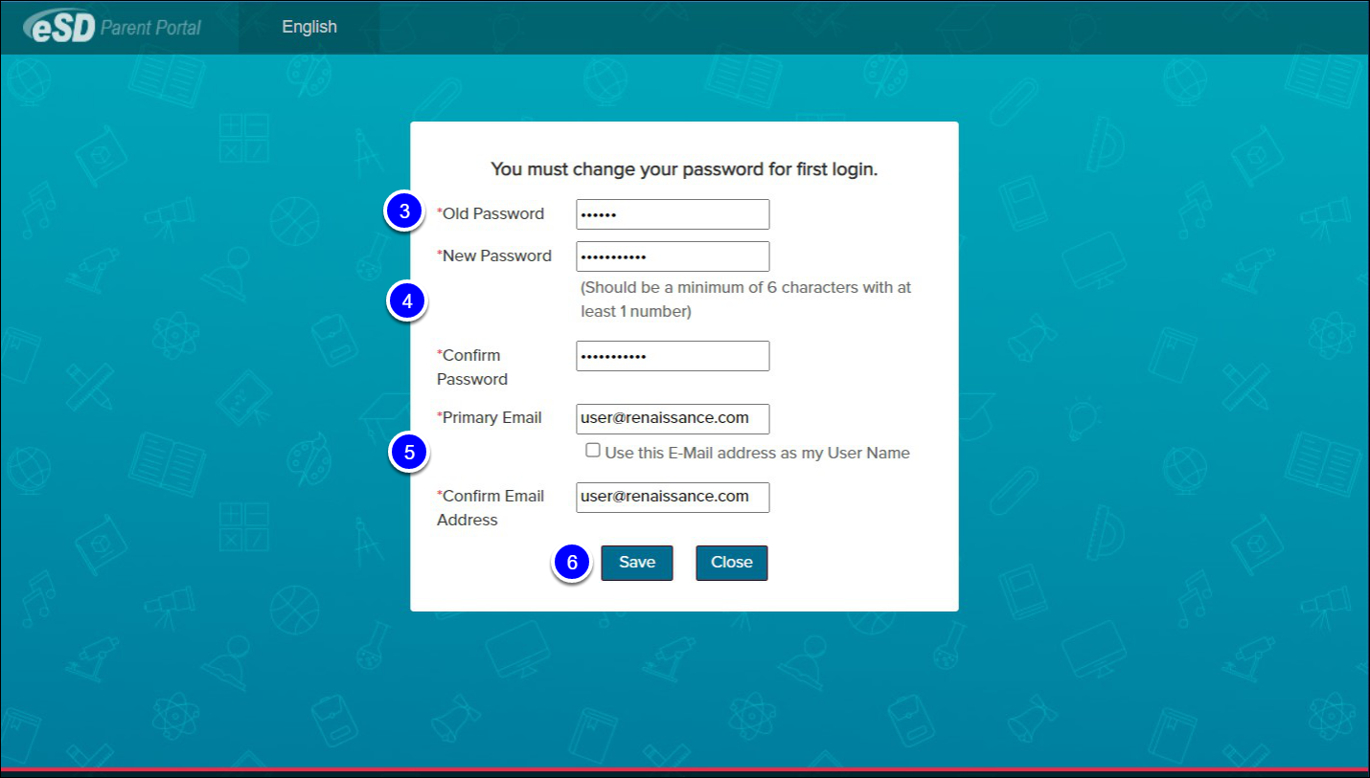
- Enter your Old Password.
- Enter a New Password and re-enter in the Confirm Password space. It should be a minimum of 6 characters with at least 1 number.
- Enter your Primary Email and re-enter in the Confirm Email Address space. Your Primary Email address is the address to which “Forgot Password?” emails are sent. Use the checkbox if you wish to use your email address as your username going forward.
- Select Save to continue.
To maintain the integrity of the database and security of student information, a primary email address cannot be shared with more than one person, even if that person is you! Parents who have children attending more than one school district will either need to use a different primary email address, or work with your district’s parent portal administrator to create a generic user name.

Portal Navigation
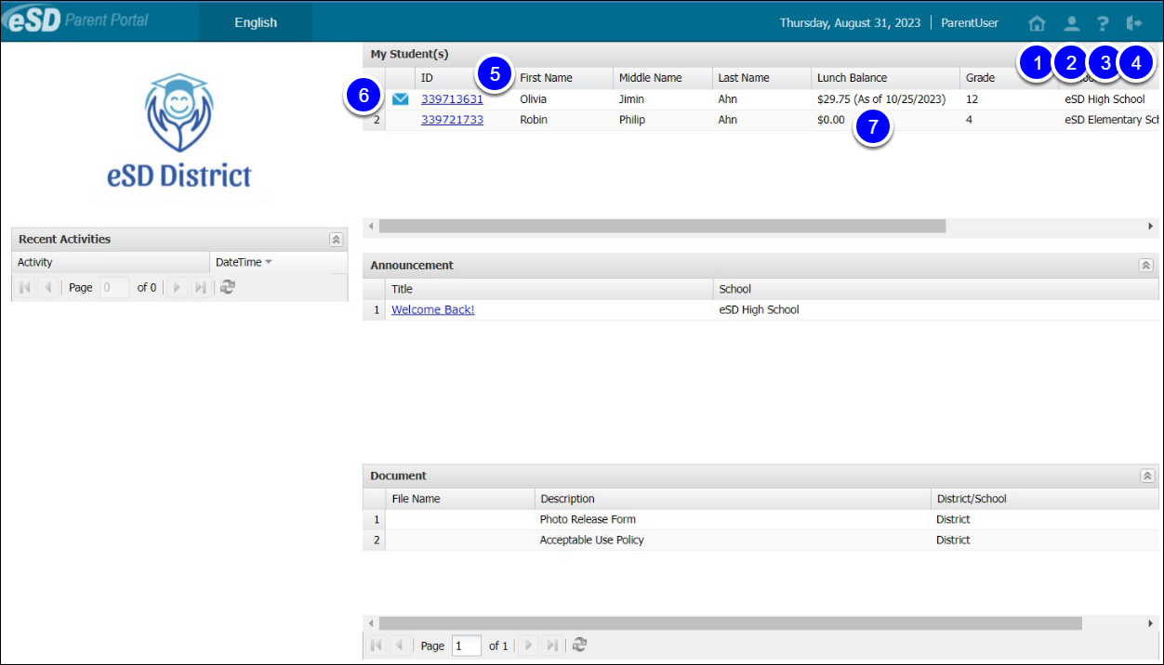
- The Home icon takes users back to the page shown above at any time.
- Use the My Account to update various account settings including account information, personal information, environmental settings, messaging preferences, and student picture settings.
- The Help icon opens a new window to the Parent Portal FAQ, which provides answers to commonly asked questions.
- Select the Logout icon to securely log out of the parent portal.
- Select the hyperlinked Student ID Number in the list of My Students to access student information.
- Select the Inbox icon or the New Message icon to access the Messages Inbox.
- If enabled by your district, the My Students list displays the Lunch Balance for each child, and the date that the Lunch Balance was last updated.
The My Students list includes graduated students for one year following graduation.

Other Features and Functions

Messages
The Messages function allows parents/guardians to easily communicate with teachers within the portal. Parents/guardians can access the Messages inbox for a student in two ways: from the My Students list on the Portal homepage and from the icon toolbar when viewing the student’s information.
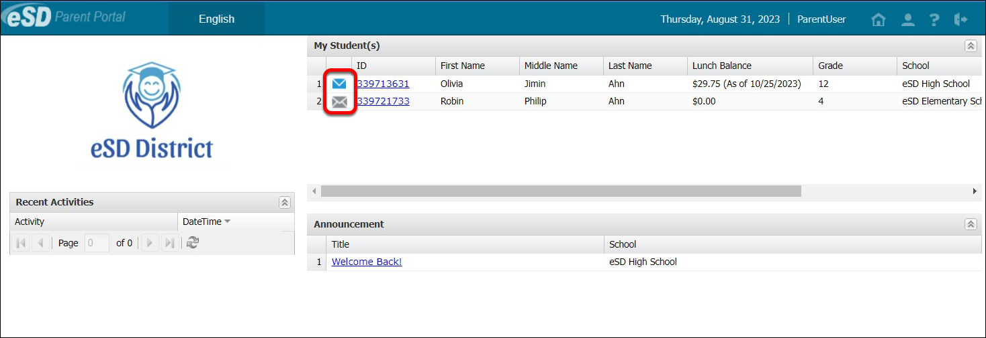
On the Portal homepage, the Messages icon displays a grey envelop icon, when there are no new messages. A blue New Message icon displays when messages are unread. Select the Messages icon to access the Messages Inbox for each student.

Messages Inbox
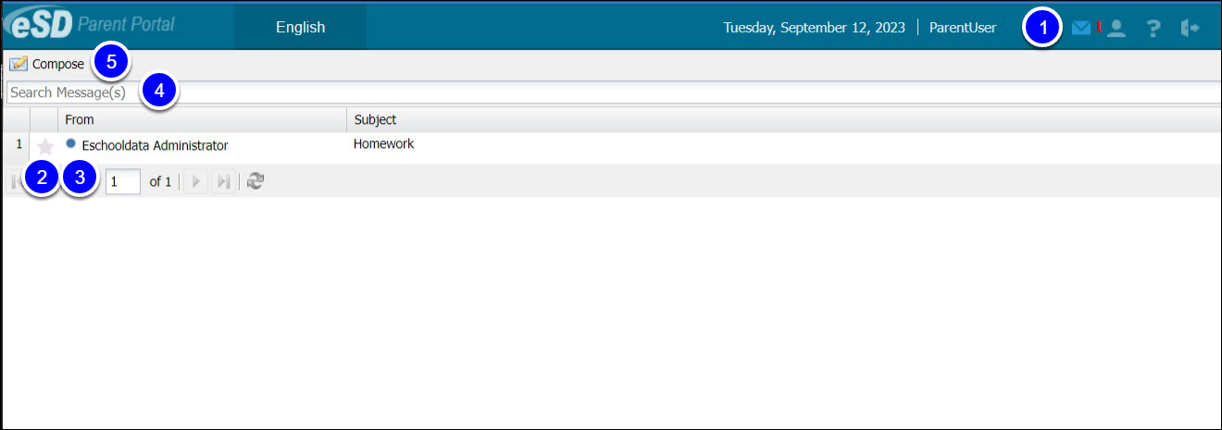
- Within the Inbox, and the Student Information pages, the Messages icon will display in the icon bar at the top right and may be followed by a red numeral to indicate the number of new, unread, messages pending. Select the icon to view a summary of recent messages.
- Select the Favorite icon to bookmark a message thread.
- The New Thread icon will display on each unread message. Click a message to view the message thread details and/or reply to the message.
- Type a search term in the Search Messages field and click the Search icon to filter the list of messages.
- Select Compose to create a new message.

Existing Message Threads
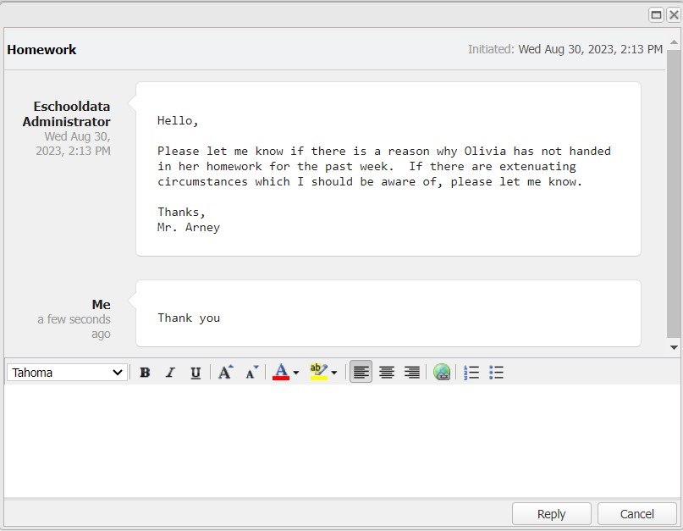
The existing Message window is divided into two areas: the message thread details at top and the reply field below, with the Editor toolbar at the top of the reply field. Type your response in the reply field and click Reply to send the response to all participants in the conversation.

Compose a New Message
After selecting Compose from the Inbox:
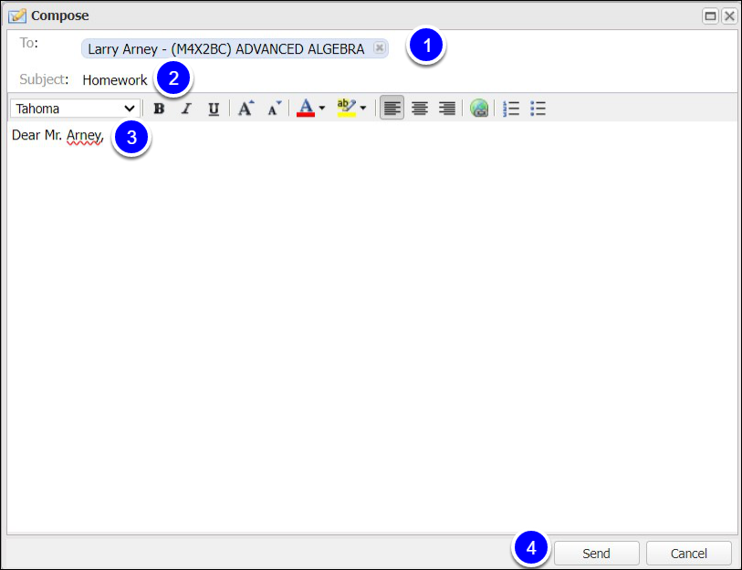
- Type the student’s name in the To: field to display a list of teachers, then select a name to select the recipient. Repeat the process to select additional recipients to create a group message.
- Enter a Subject line.
- Enter the message body. The Editor Toolbar allows users to customize text, insert a link, or create lists.
- When finished, select Send.

Contact Verification
When enabled by the district, the Contact Verification Form allows custodial Guardians to update their student’s contacts online.
Online Contact Verifications allow parents to provide up-to-the-minute contact information, eliminating the need for paper forms to be manually entered into the student management system.
Contact Verification can either be available as an option, or parents can be forced to verify contact information before accessing student information. When enforced, the Contact Verification Form will open automatically. Once the form is completed by at least one household guardian, parents are no longer forced to update the information; however, contact information as necessary throughout the year.
Select your student's name or ID to access their profile:
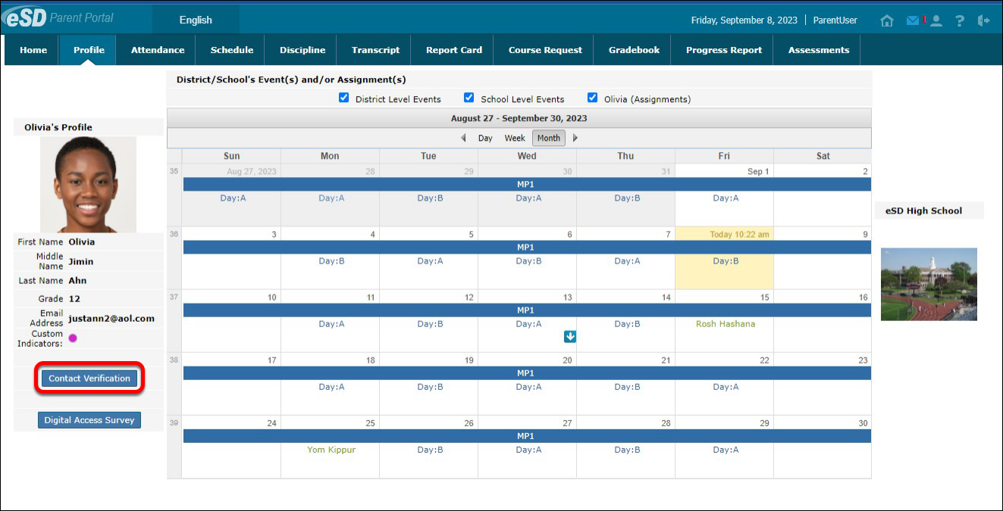
Select the Contact Verification button to open the Contact Verification form.
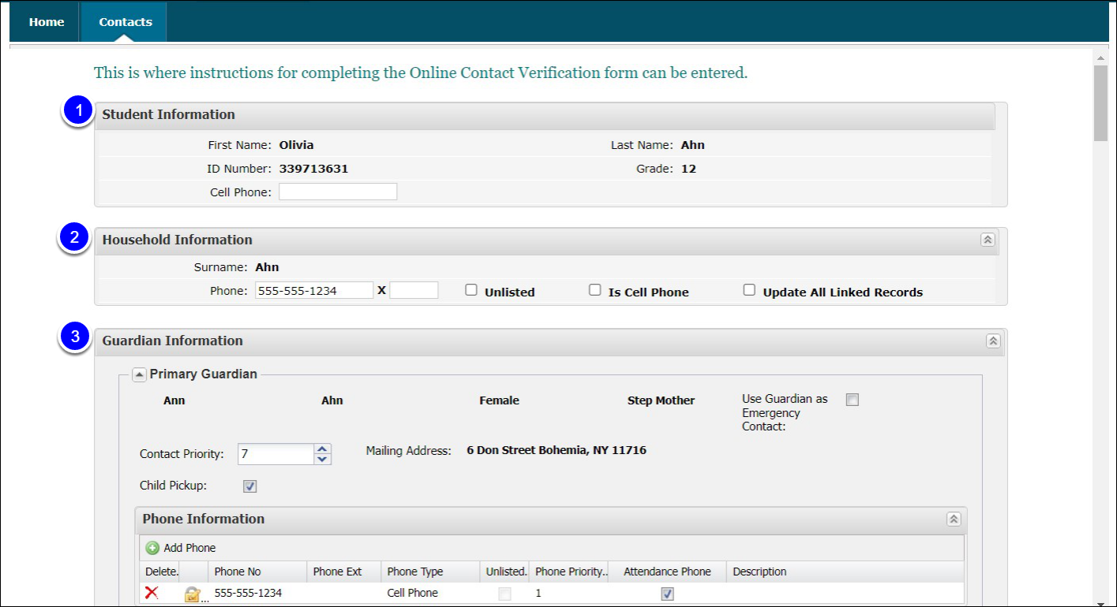
- In the Student Information section, add/update the student’s Cell Phone.
- In the Household Information section, update the Household Phone. Click Update All Linked Records to update the Home Phone record for all contacts (Guardian, Household Member, and Emergency Contact) who have the Household Phone as their Home Phone. (Linked records display a Lock icon C:\Users\pmartin\Pictures\Icons\Reset Password.jpg to the left of the applicable phone number.)
- In the Guardian Information section, update the Contact Priority. Contact priority is used to determine the guardian who should be called first, second, third, etc. Phone priority defines the first phone number to call for each contact. For example, contact Dad first, and try his personal cell phone first, then try his work phone number if you cannot reach him on his personal cell.
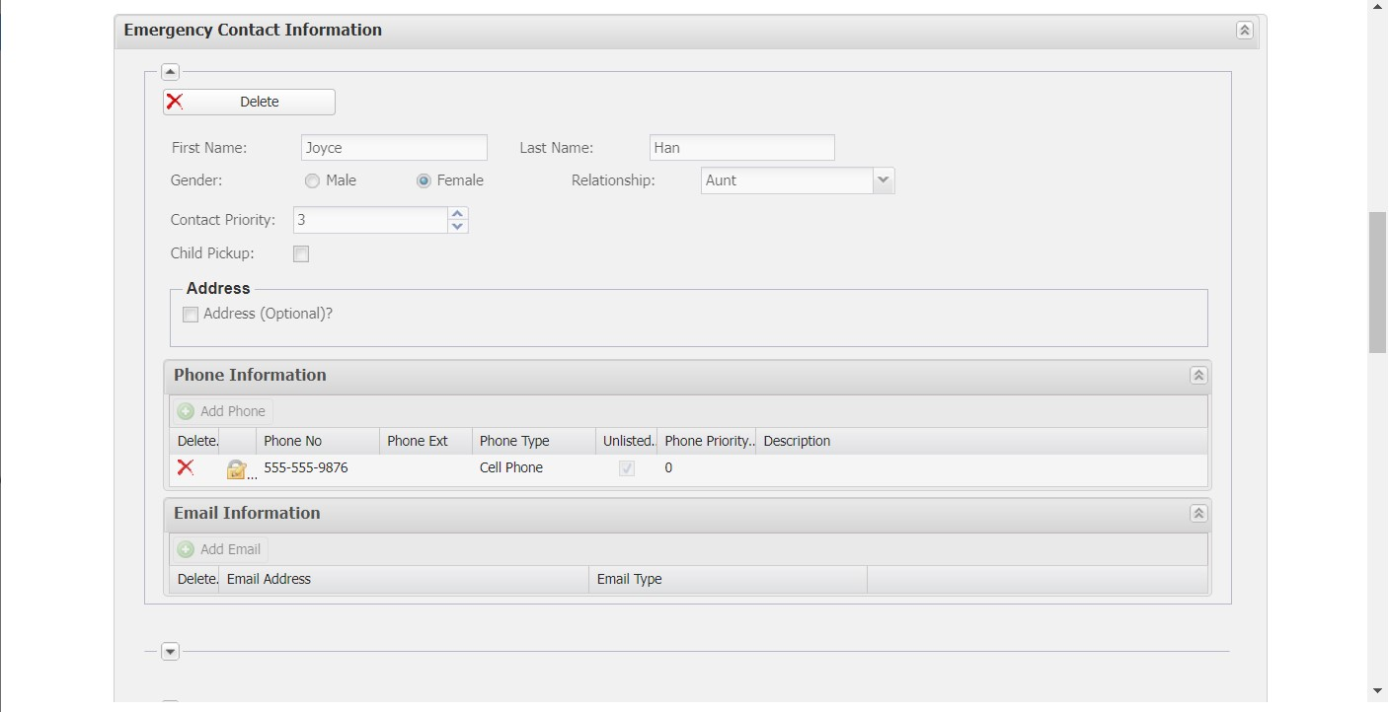
- The Emergency Contact Information section, add/delete/update emergency contact information. Select the Child Pick checkbox to indicate the emergency contact is also authorized to pick the student up from school.
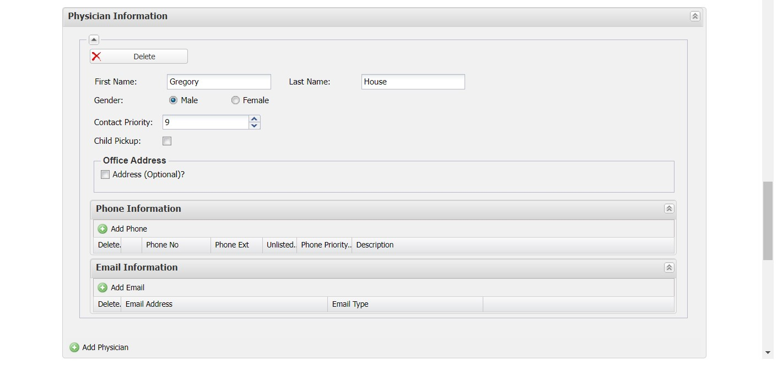
- In the Physician Information section, add/delete/update physician information.
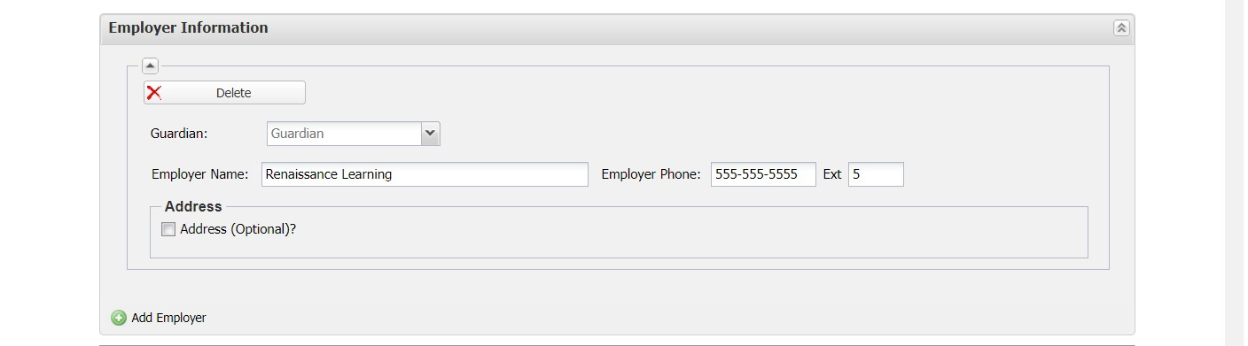
- Employer Information is optional. Use the red check to delete the section entirely, if desired.
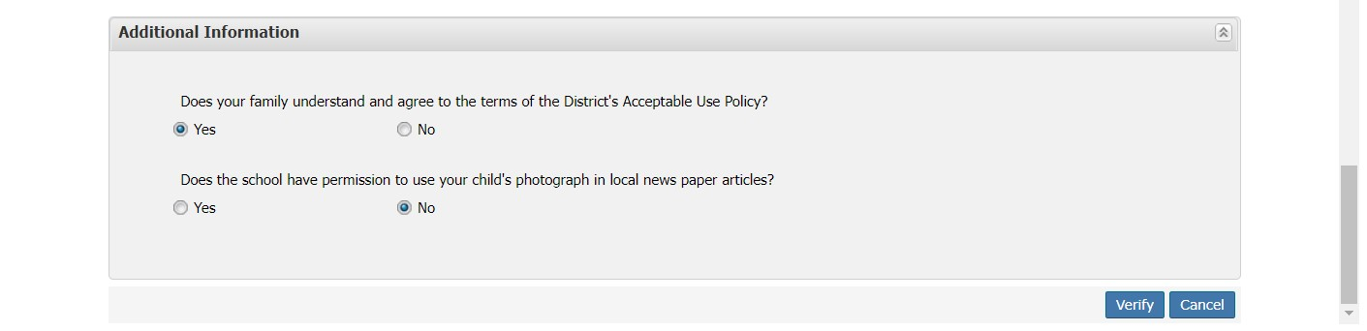
- In the Additional Information section, add/update any additional information requested by the district. When finished, select Verify to submit the verified contact information; the changed records are automatically updated in eSchoolData.

Digital Access Survey
Schools must ensure that students have equitable digital access to the internet and to electronic devices by surveying the school community each fall. The results must then be reported to the state. Completion of the digital access survey via the eSD portal helps the school district meet this mandated requirement.
Select your student's name or ID to access their profile:
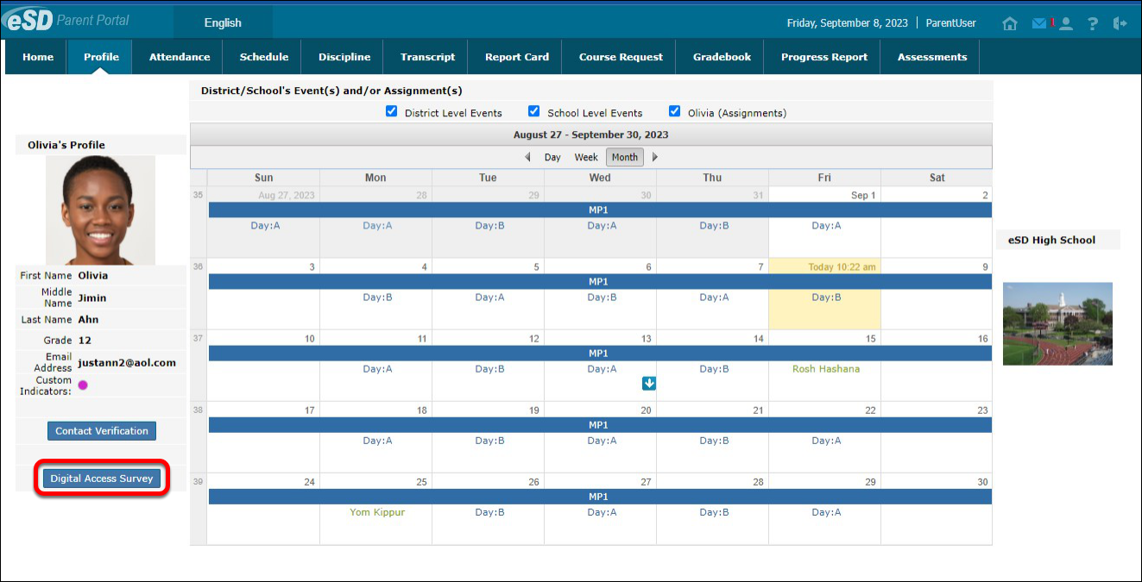
- Select the Digital Access Survey button.
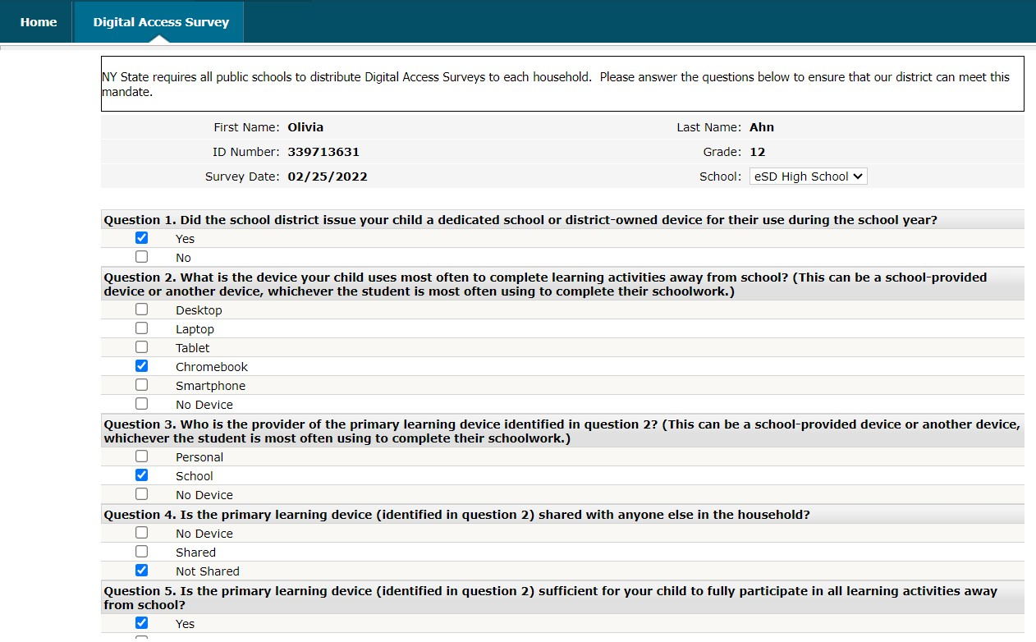
- Answer all questions on the survey. Select Save when complete.

Student Information Pages

Profile Tab
After select the student's name or ID, you are directed to the Profile tab.
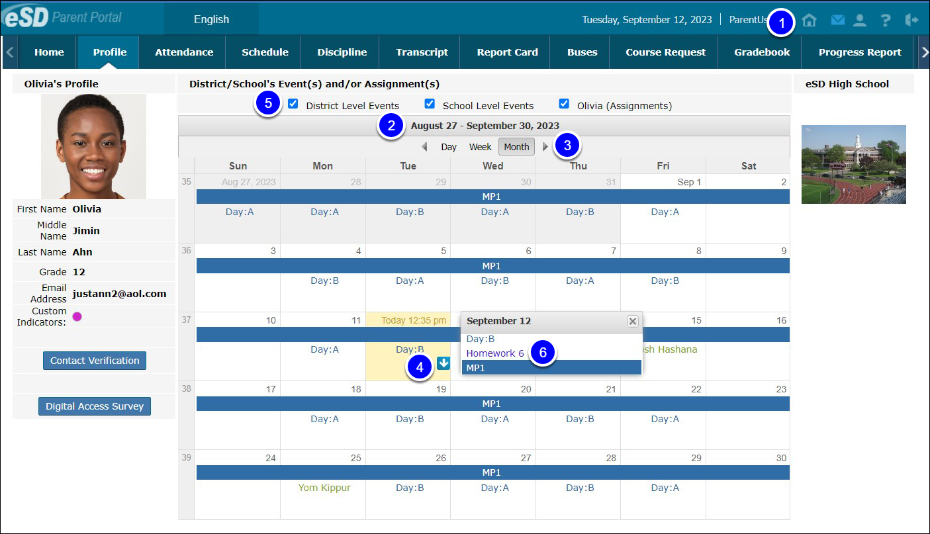
- Messages for the individual student can be access at the top right of the page.
- By default, the calendar displays the current Month, and all District Level and School Level Events along with the selected student’s Assignments.
- Select the Forward and Back arrows to display another date range.
- If there are more events on a calendar date than can be displayed, that date box will show the More Events icon.
- Parents/guardians can change the amount of information displayed by checking/unchecking the Event boxes.
- Select an Assignment to open the Assignment Details window. The Grade (if shown) will display as Earned/Possible Points. The description of the Assignment may contain a hyperlinked URL, if included by the teacher.

Attendance Tab
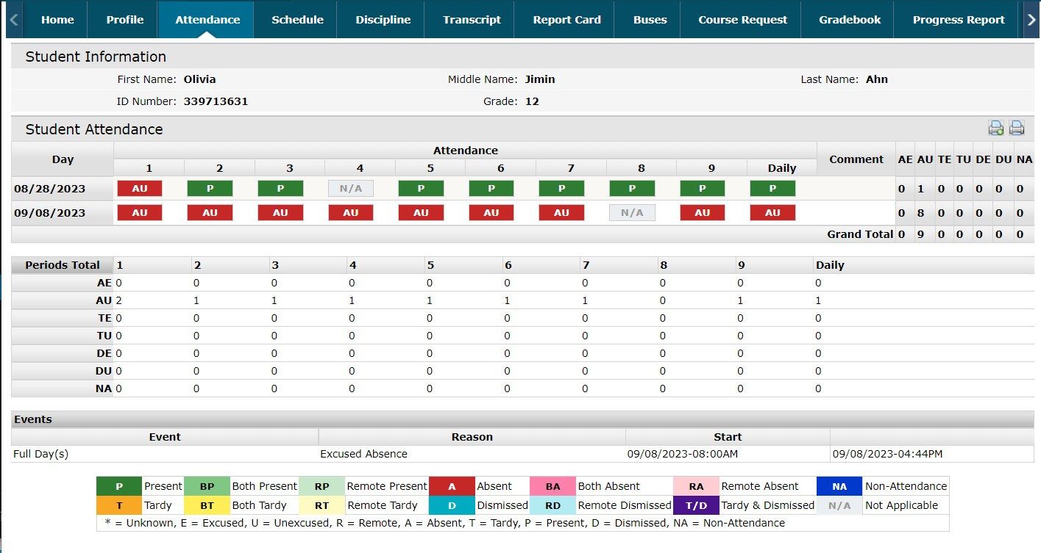
The Attendance tab displays student's Daily/Period Attendance, Comments, and Attendance Events based on settings established by the school.

Schedule Tab
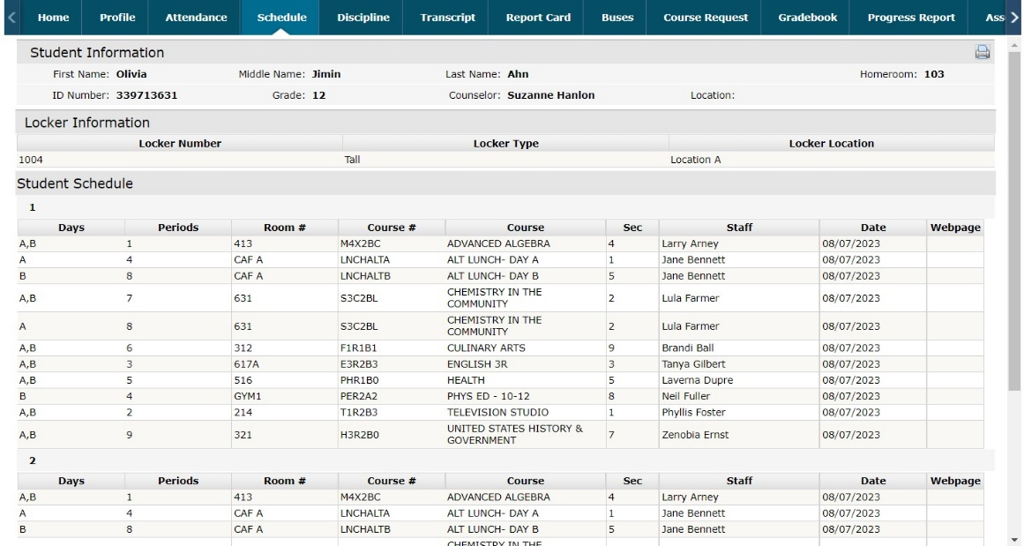
The Schedule tab to view the student’s schedule. The Partially Scheduled icon pre_sch denotes the student is not expected to attend classes based on the standard day pattern associated with the class. For example, a study hall may meet on Monday – Friday, but if the student is only free on 3 of the 5 days, this is considered “partial scheduling”. If an icon appears in the Webpage column, clicking the icon will direct the user to the teacher’s personal Webpage.

Discipline Tab
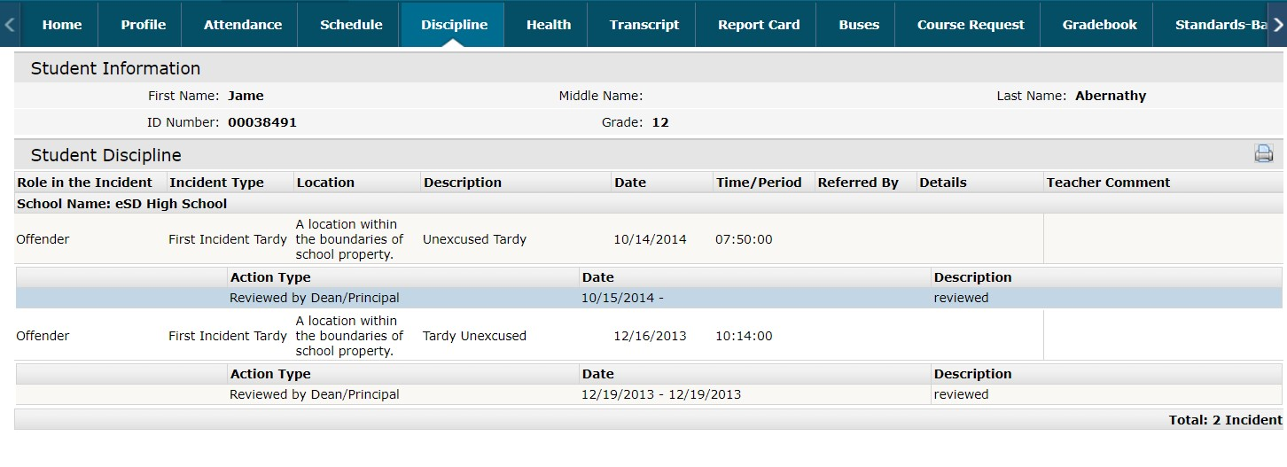
The Discipline tab displays select discipline events which the school has published to the parent portal.

Health Tab
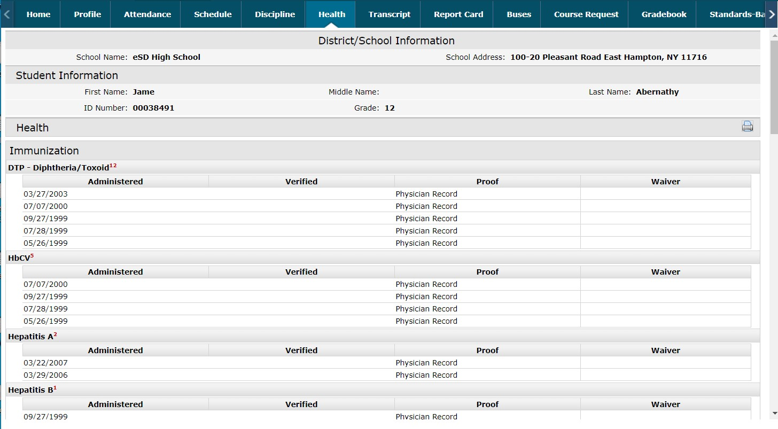
The Health tab displays student’s immunization records on file with the district.

Transcript Tab
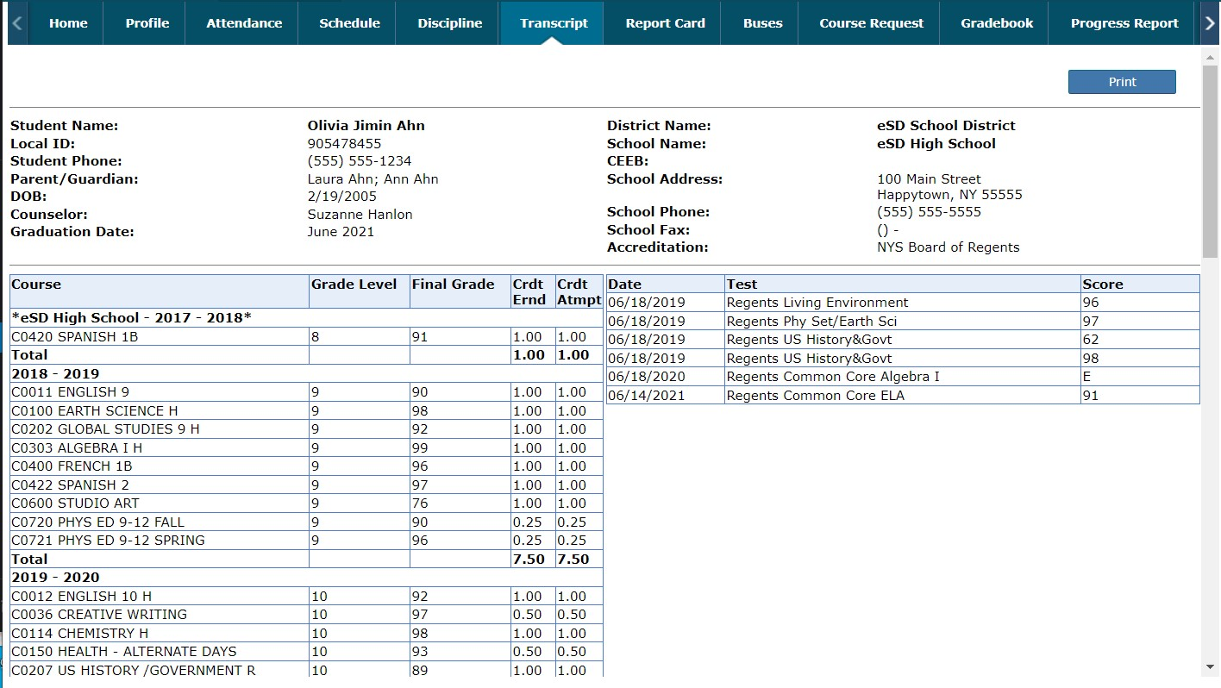
The Transcript tab displays the most recently published, unofficial student transcript.

Report Card Tab
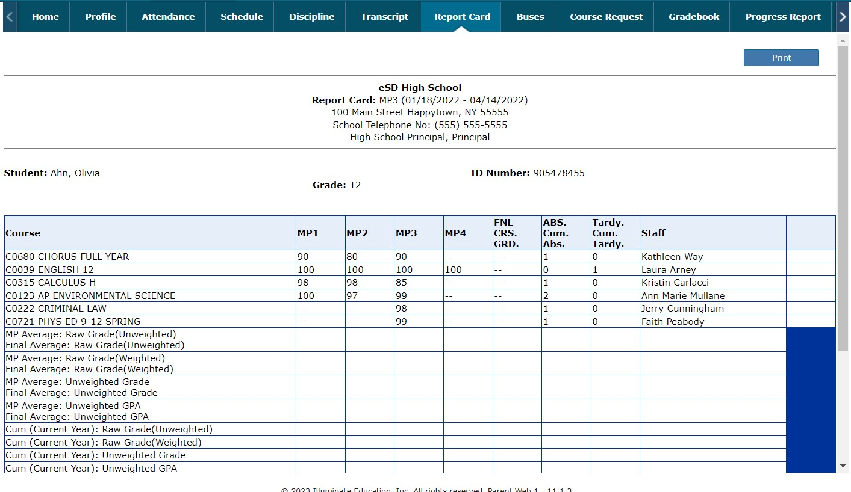
The Report Card tab displays the most recently published Report Card.

Buses Tab
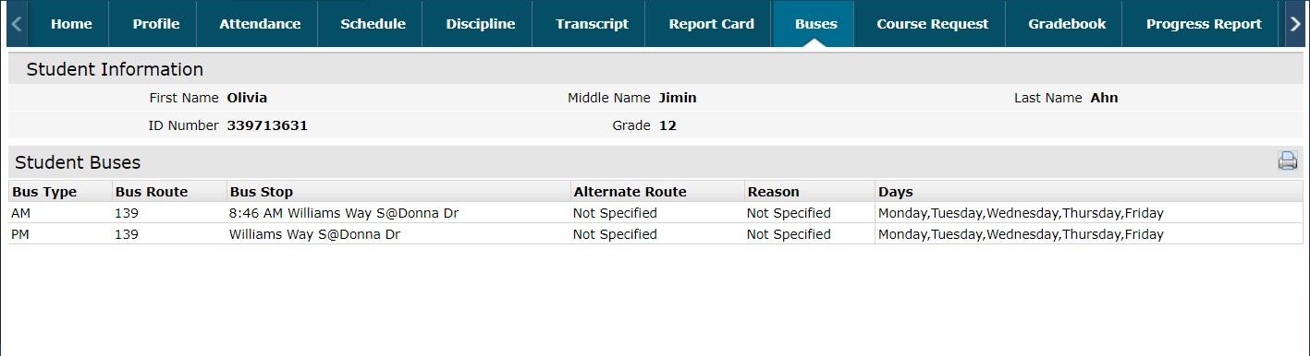
The Buses tab displays student bus information.

Course Requests Tab
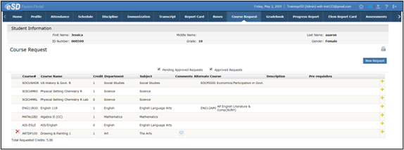
Depending on the district’s policy and settings, parents/guardians will be able to enter new Course Requests by select the New Request button. When enabled, parents/guardians will be able to enter Alternate Course Requests by selecting the Add Alternate Course Request icon (+).

New Course Request
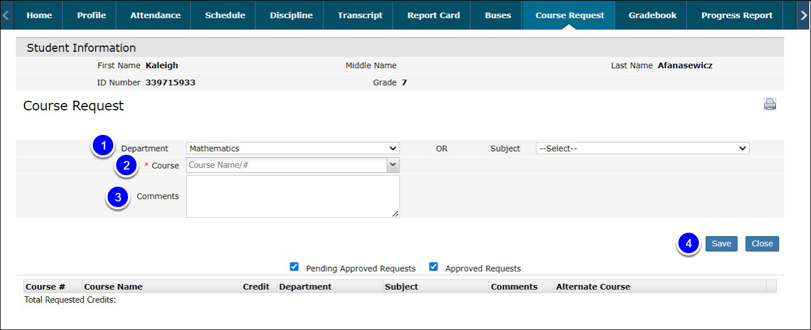
After selecting New Request:
- Use the Department or Subject field to narrow the list of available courses.
- Select a course from the list or type the Course Name or Number into the Course field.
- Open the Course menu to Comments can be added if desired (New Course Requests only).
- Select Save to add the request.
If the course has a pre-requisite that the student does not meet, the Pre-Requisite Not Met message box will appear, detailing the course pre-requisite. To be considered for the course, enter Comments, and select OK; otherwise, select Cancel to close the message box and select another course.

Gradebook Tab
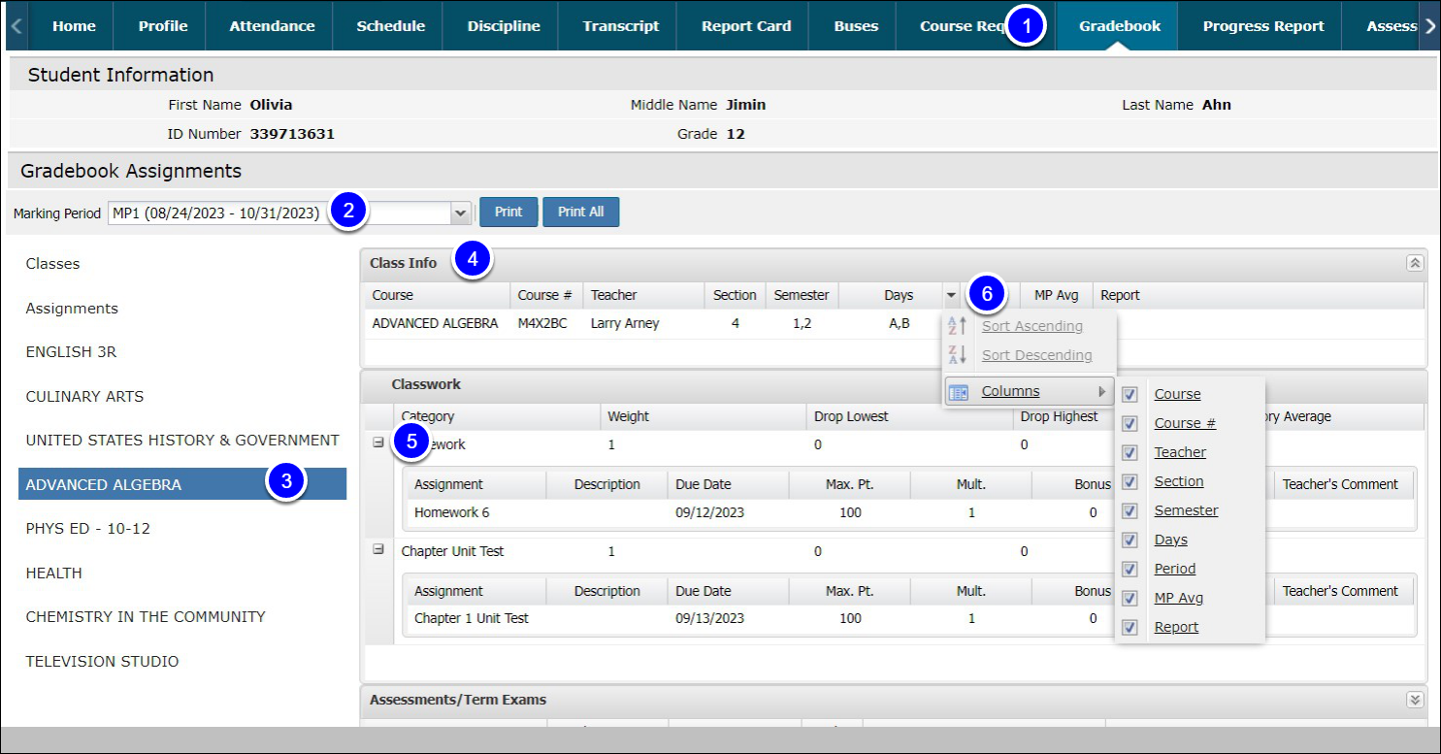
- Select the Gradebook tab to view the student’s classes list and published assignments. The Gradebook Assignments window is broken into two sections.
- Change the Marking Period (defaults to the current Marking Period) from the drop-down menu
- Select Assignments to view all class assignments, and select a course in the Classes List to view specific details.
- Class information and assignment details appear in a table. Select the Assignment Description icon to view the assignment description, which may contain relevant external URL links. Assignments with associated Learning Standards will display the Learning Standard name within parentheses after the assignment name. The Teacher’s Comment column will display assignment-specific comments.
- Use the Expand icon next to an Assignment Category to display the published assignments in that category.
- Hover over a column header and select the Menu icon to open the menu. Users can sort by that column (ascending or descending) and change the displayed columns.

Progress Reports Tab
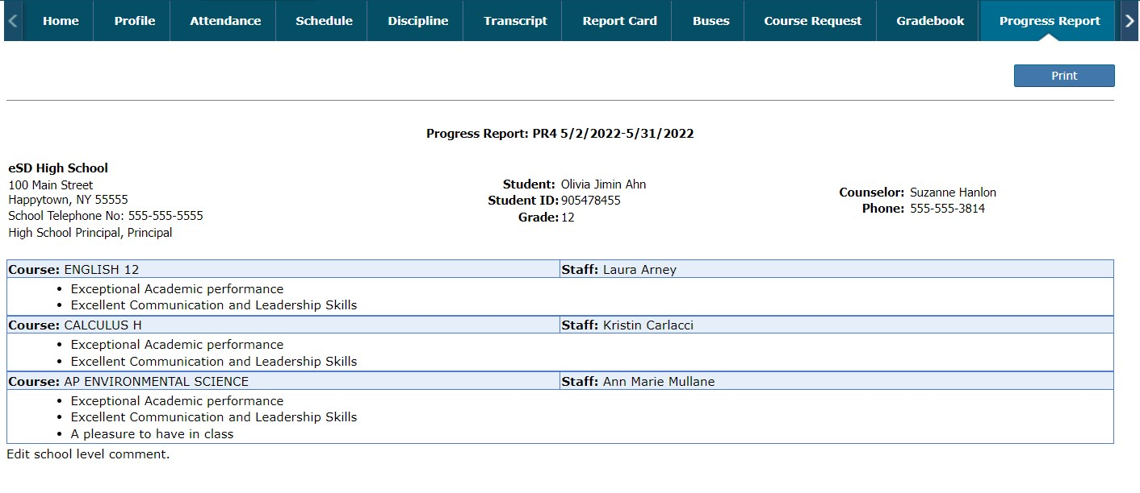
The Progress Report tab displays the most recently published Progress Report.

Assessments Tab
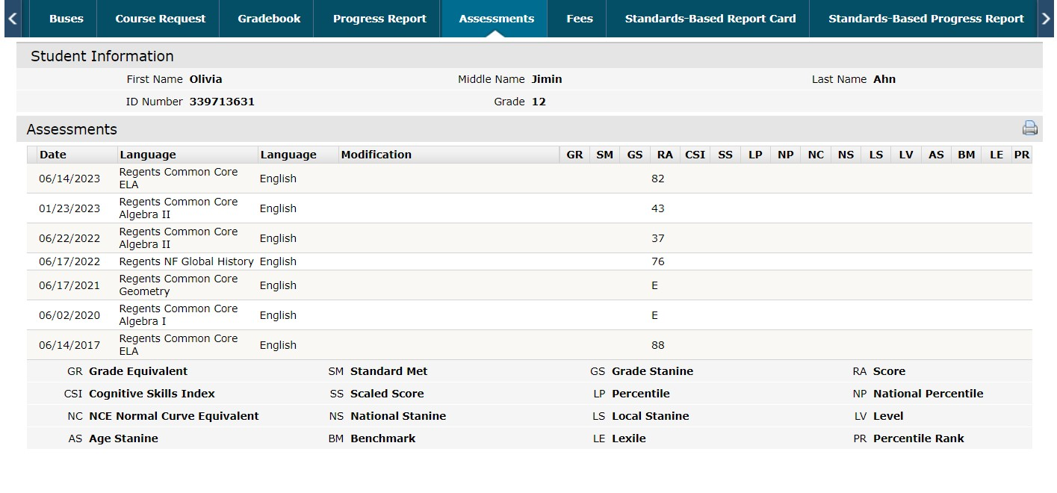
The Assessments tab displays student assessments which have been published to the portal. If enabled, a Parent Assessment Report option will open a detailed report of student assessments.

Fees Tab
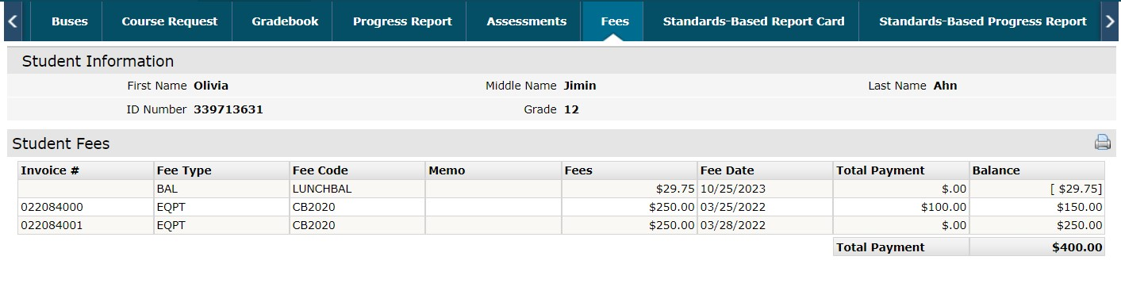
The Fees tab displays student’s fees. Invoice information and total balance will be displayed.

Standards Based Report Cards Tab
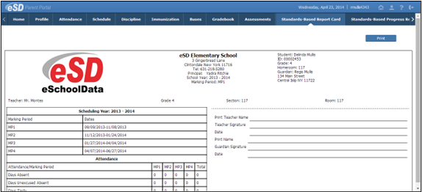
The Standards-Based Report Card tab displays the most recently published Standards-Based report card.

Standards Based Progress Reports Tab
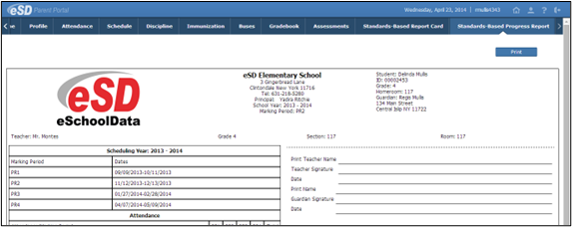
The Standards-Based Progress Report tab displays the most recently published Standards-Based progress report.

Account Settings

Update Account Information
After selecting the My Account icon at the top right hand corner of the portal, the Update Account Info tab is the default tab.
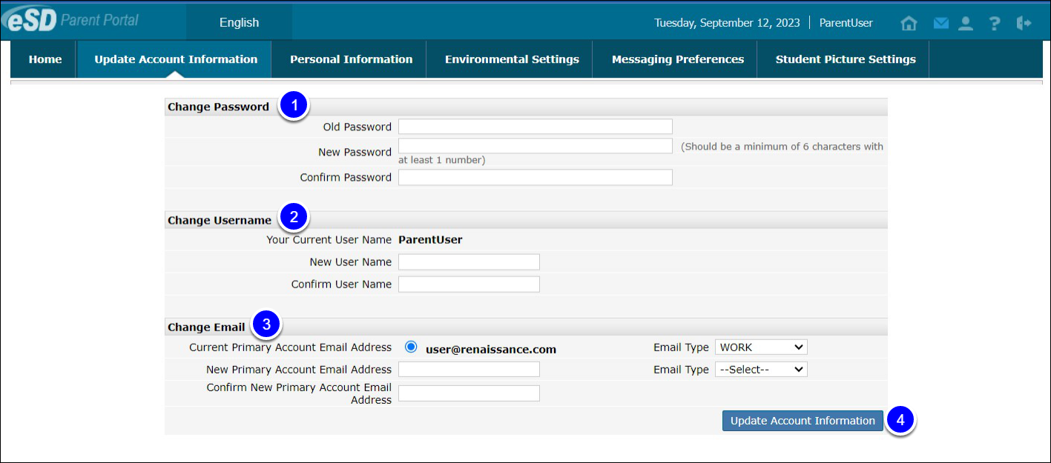
- To change your Password, enter your existing password, then enter a new password and confirm it.
- To change your Username, enter your new desired username and then confirm it.
- The Current Primary Account Email Address will be indicated in the list of email addresses associated with the Guardian’s record. Select a different email address as the Current Primary Account Email Address and the appropriate Email Type for that address OR enter the New Primary Account Email Address and select the Email Type for the new email address. An error message will be presented if the New Primary Account Email Address is already used within the district as another person’s Primary Account Email Address.
- Enter the latest information in one or all these categories and select Update Account Information when finished.

Personal Information
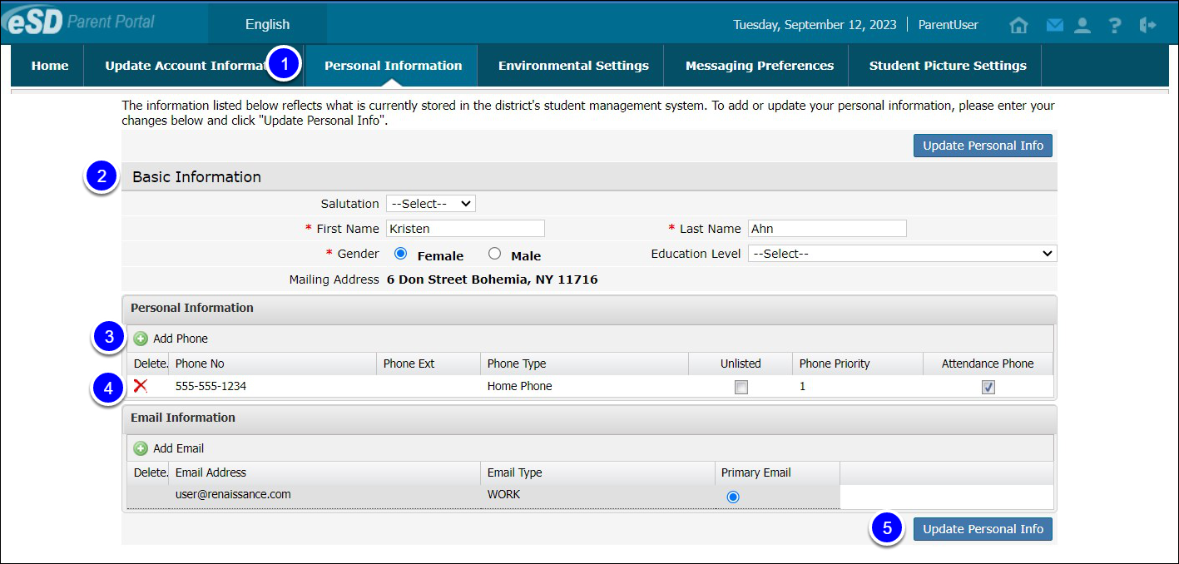
- When enabled by your district, select the Personal Information tab to request changes to your personal information. This option is typically not enabled in districts using the Contact Verification form.
- The following fields can be updated: Salutation, First Name, Last Name, Gender, Education Level, Phone Information and Email Information.
- Additional phone numbers and email addresses can be added using the Add Phone and Add Email buttons.
- Select the Delete icon Delete to delete an existing phone number or email address.
- Select Update Personal Info when finished to submit the change request. Portal administrators have the option to accept or ignore change requests.

Environmental Settings
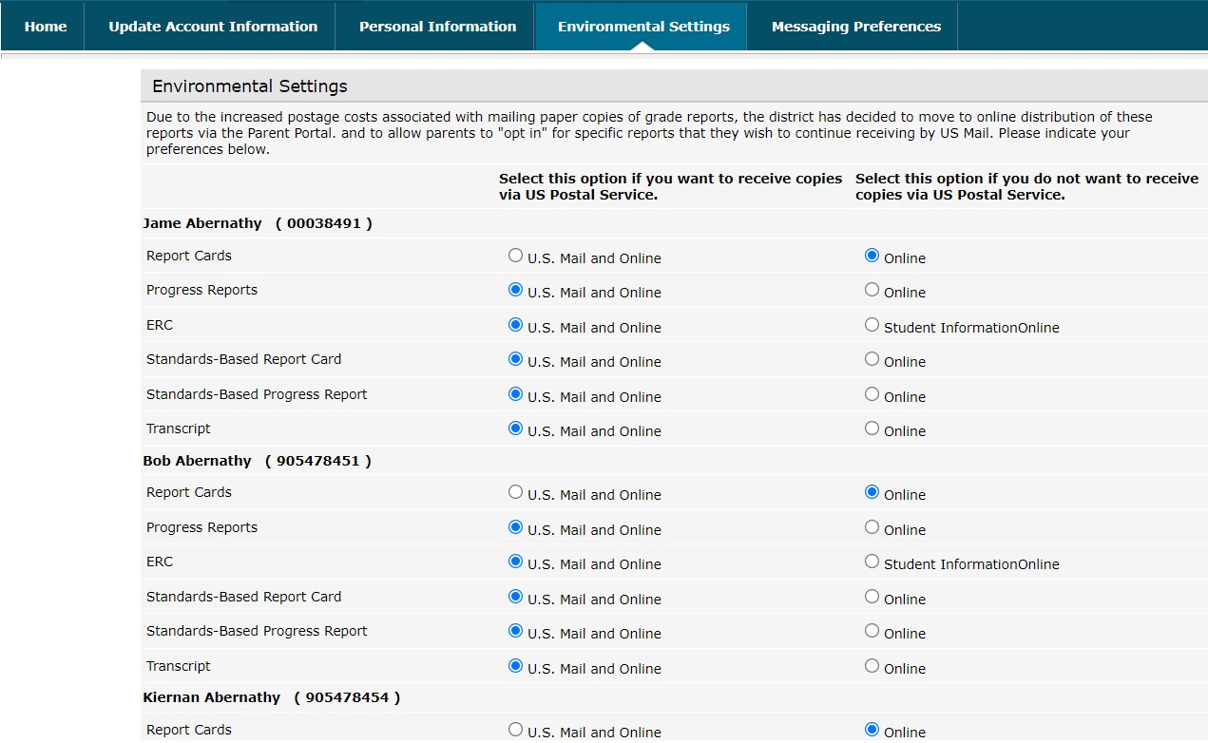
Parents/guardians will have access to the Environmental Settings tab if the school district is implementing a “Go Green” initiative to reduce the mailings of grade reporting documents.
For each student, parents/guardians can select which available grade reporting documents they wish to receive as paper mailings. Select Update Settings when finished.

Messaging Preferences
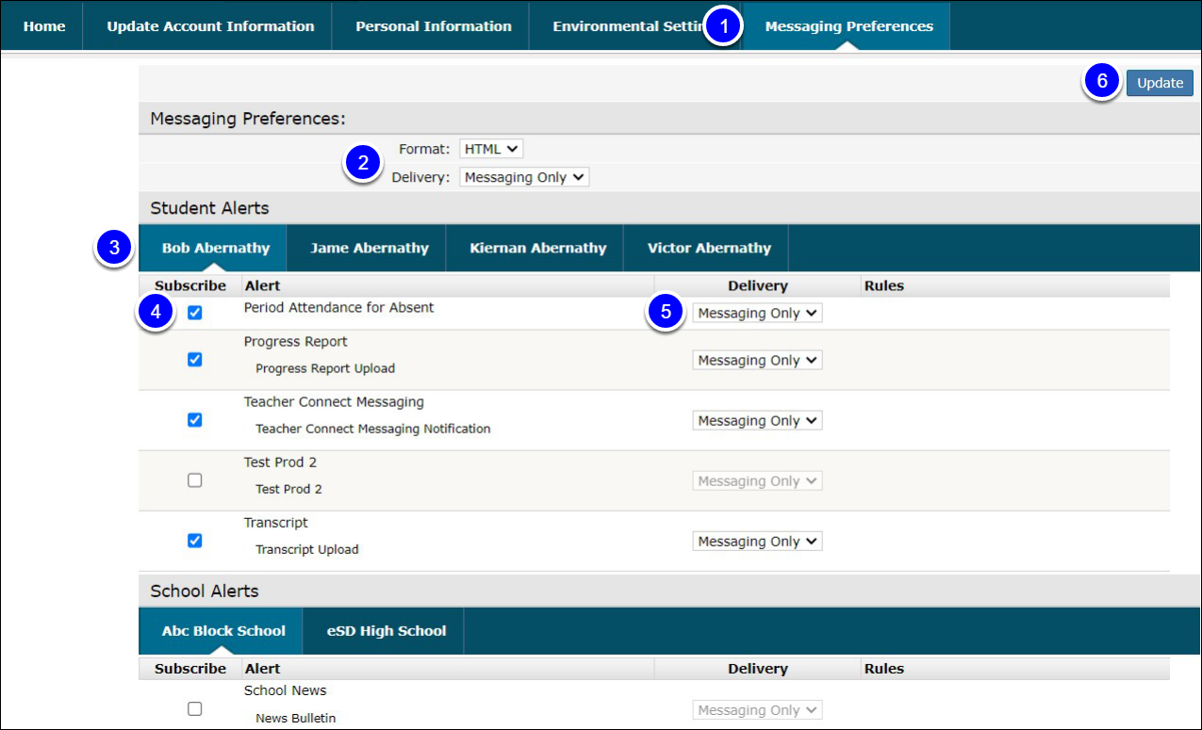
- Select the Messaging Preferences tab. When enabled by your district, the Messaging Preferences tab allows you to subscribe to email alerts and set the email formats and delivery schedules.
- The Messaging Preferences section allows you to set the default options for email Format and Delivery schedule. Format: HTML or Text Delivery: Individual E-Mails, Daily Digest, Weekly Digest, Monthly Digest, Messaging Only Student Alerts / School Alerts.
- Select each student and each school to view the Alerts applicable to that student/building.
- Check/uncheck Subscribe to change the default settings for each alert. Check to receive alert, uncheck to stop.
- Set the Delivery method for each subscribed alert. Select the applicable schedule, if different from the Preferences selection.
- Select Update to save changes.

Picture Settings
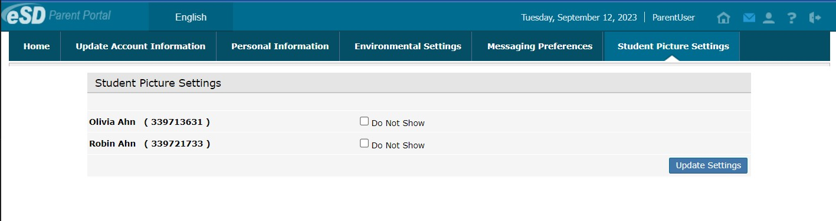
When enabled by your district, the Picture Setting tab allows you to control whether your child’s photo is displayed on the eSD® Portals. Check the Do Not Show checkbox to hide your child’s photo. Click Update Settings when finished.

